Addison Babcock

Addison.babcock@hotmail.com

Abstract

Lab 1 - Construction Phase Documentation

Construction Documentation

Table of Contents

Transition Iteration 1 Plan 2

Transition Iteration 1 Schedule 2

Domain Model 3

Design Class Diagram 4

Data Model 5

Data Dictionary 5

Data Model Classes 8

GolfCourse.cs 8

Member.cs 8

Score.cs 9

TeeTime.cs 10

Database Tables 11

# Transition Iteration 1 Plan

|  |  |  |  |  |  |  |
| --- | --- | --- | --- | --- | --- | --- |
| Discipline | Use Case | Activities | Estimated Hours | Actual Hours | % Completed | Resources |
| Learning | Learning new technologies | Watching Pluralsight videos | 20 | 20 | 100% | Developer |
| Set up Azure site and database | Initial Configuration | Azure configuration | 5 | 5 | 100% | Lead developer |
| Set up Github repository | Initial Configuration | Github configuration | 1 | 1 | 100% | Lead developer |
| Create Data models | Initial Development | Create classes for data model | 5 | 10 | 100% | Developer |
| Set up debug connection for localdb | Initial Development | Create data connection | 1 | 1 | 100% | Developer |
| Create global layout | Initial Development | Create UI | 5 | 10 | 100% | Developer  Designer |
| Create Registration UI | Registration | Create classes and UI forms | 6 | 5 | 100% | Developer  Designer |
| Create Reservation UI | Reservation | Create classes and UI forms | 12 | 3 | 100% | Developer  Designer  DBA |
| Create Standing Reservation UI | Standing Reservation | Create classes and UI forms | 12 | 1 | 100% | Developer  Designer  DBA |
| Create Enter Score Functionality | Enter Score | Create classes and UI forms | 6 |  | 0% | Developer  Designer  DBA |
| Create Member Profile Functionality | View/Update Profile | Create classes and UI forms | 18 |  | 0% | Developer  Designer  DBA |
| Create Admin Login UI | Admin Login | Create classes and UI forms | 6 | 1 | 100% | Developer  Designer  DBA |
| Modify Registration UI for Admins | Admin Add Member | Modify UI | 6 | 1 | 100% | Developer  Designer |
| Create Update Reservation UI for Admins | Admin Update Reservation | Create UI forms | 6 |  | 0% | Developer  Designer |
| Modify Create Reservation UI | Admin Create Reservation | Modify UI | 6 |  | 0% | Developer  Designer |

## Transition Iteration 1 Schedule

Phase: Iteration

|  |  |  |  |  |
| --- | --- | --- | --- | --- |
| Iteration | Minor Milestone | Start Date | End Date | Resources |
| 1 | Beta | March 15, 2016 | March 29, 2016 | Developer, Tester (2), Designer, DBA |

# Domain Model



# Design Class Diagram

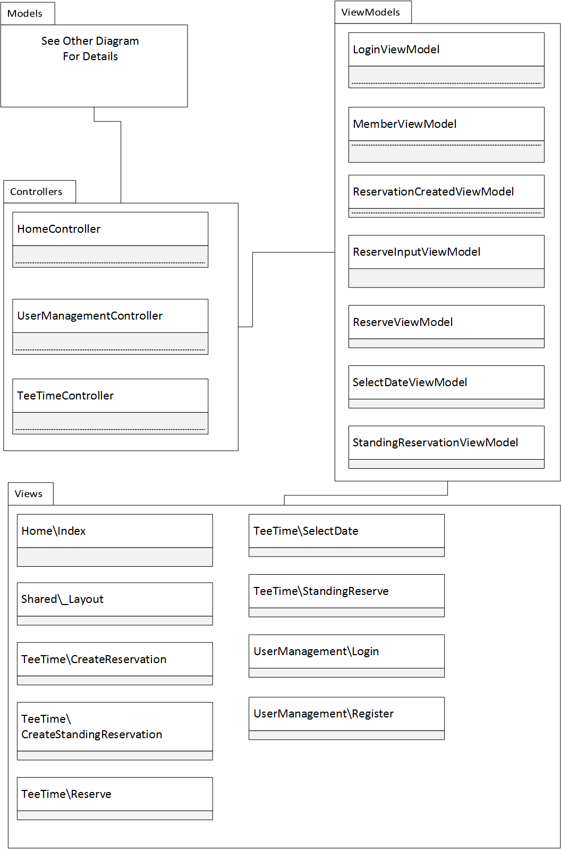

# Data Model

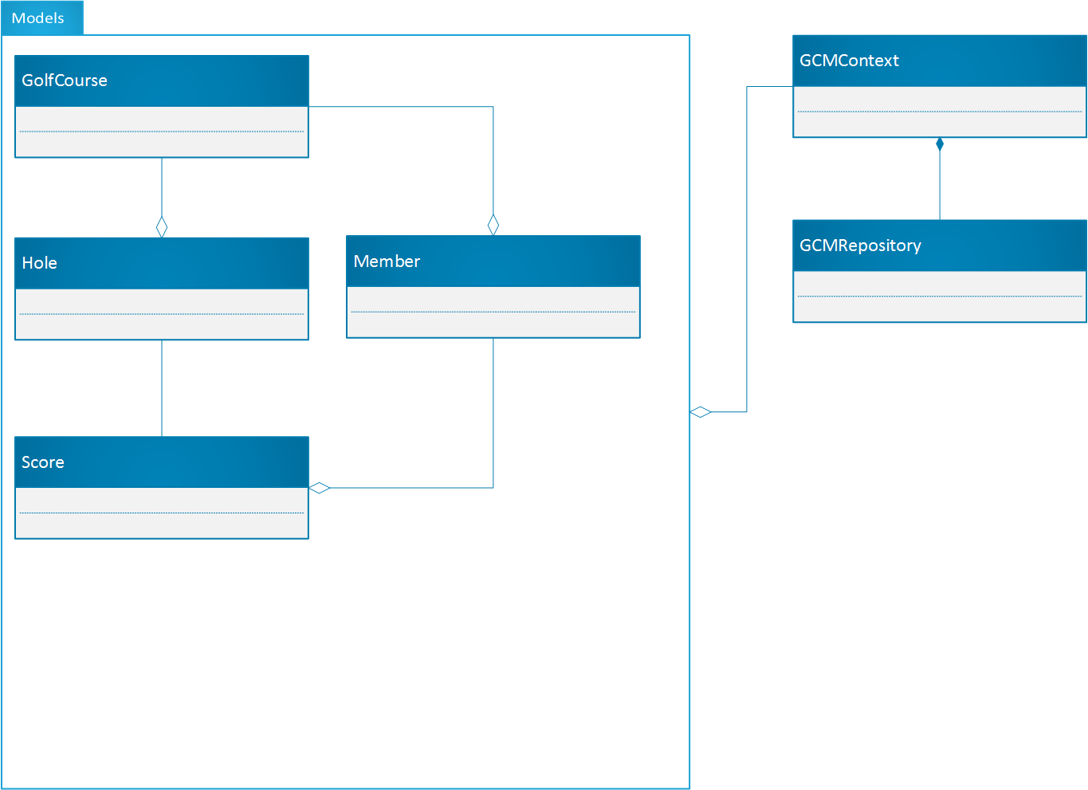

# Data Dictionary

Table: GolfCourse

Columns:

* ID: Int, PK
* Name: String
* TeeTimeInterval: Time
* MondayOpen: Time
* MondayClose: Time
* TuesdayOpen: Time
* TuesdayClose: Time
* WednesdayOpen: Time
* WednesdayClose: Time
* ThursdayOpen: Time
* ThursdayClose: Time
* FridayOpen: Time
* FridayClose: Time
* SaturdayOpen: Time
* SaturdayClose: Time
* SundayOpen: Time
* SundayClose: Time

Table: AspNetUser

Columns:

* Id: String, PK
* GolfCourseID: Int, FK
* FirstName: String
* LastName: String
* Address1: String
* Address2: String
* Address3: String
* City: String
* Province: String
* PC: String
* Status: String
* Username: String
* PasswordHash: String
* AccessFailedCount: int
* ConcurrencyStamp: String
* Email: String
* EmailConfirmed: bit
* LockoutEnabled: bit
* LockoutEnd: DateTimeOffset
* NormalizedEmail: String
* NormalizedName: String
* PhoneNumber: String
* PhoneNumberConfirmed: Bit
* SecurityStamp: String
* TwoFactorEnabled: Bit

Table: TeeTime

Columns:

* Id: int, PK
* MemberID: string, FK, Null
* GolfCourseID, int, PK
* Player1: String
* Player2: String
* Player3: String
* Player4: String
* Start: DateTime, Unique

Table: Score

Columns:

* Id: Int, PK
* GolfCourseID: Int, FK
* HoleId: Int, FK
* TeeTimeStart: DateTime
* MemberID: String, FK
* PlayerName: String
* Strokes: Int

Table: Hole

Columns:

* Id: Int, PK
* GolfCourseID: Int, FK
* HoleNumber: Int
* Par: Int
* YardsWhite: Int
* YardsRed: Int
* YardsBlue: Int

Table: AspNetUserClaims

Columns:

* Id: int, PK
* ClaimType: String
* ClaimValue: String
* UserID: String, FK

Table: AspNetUserLogins

Columns:

* LoginProvider: String, PK
* ProviderKey: String, PK
* ProviderDisplayName: String
* UserID: String, FK

Table: AspNetUserRoles

Columns:

* UserID: String, PK, FK
* RoleID: String, PK, FK

Table: AspNetRoles

Columns:

* Id: String, PK
* ConcurrencyStamp: String
* Name: String
* NormalizedName: String

Table: AspNetRoleClaims

Columns:

* Id: String, PK
* ClaimType: String
* ClaimValue: String
* RoleID: String, FK

# Data Model Classes

## GolfCourse.cs

using System;

using System.Collections.Generic;

using System.ComponentModel.DataAnnotations;

namespace GolfCourseManager.Models

{

public class GolfCourse

{

[Key]

public int Id { get; set; }

public string Name { get; set; }

public TimeSpan TeeTimeInterval { get; set; }

public DateTime MondayOpen { get; set; }

public DateTime MondayClose { get; set; }

public DateTime TuesdayOpen { get; set; }

public DateTime TuesdayClose { get; set; }

public DateTime WednesdayOpen { get; set; }

public DateTime WednesdayClose { get; set; }

public DateTime ThursdayOpen { get; set; }

public DateTime ThursdayClose { get; set; }

public DateTime FridayOpen { get; set; }

public DateTime FridayClose { get; set; }

public DateTime SaturdayOpen { get; set; }

public DateTime SaturdayClose { get; set; }

public DateTime SundayOpen { get; set; }

public DateTime SundayClose { get; set; }

public ICollection<Hole> Holes { get; set; }

public ICollection<Member> Members { get; set; }

}

}

## Member.cs

using Microsoft.AspNet.Identity.EntityFramework;

using System;

using System.Collections.Generic;

using System.ComponentModel.DataAnnotations;

using System.Linq;

using System.Threading.Tasks;

namespace GolfCourseManager.Models

{

public class Member : IdentityUser

{

// public int GolfCourseId { get; set; }

public string FirstName { get; set; }

public string LastName { get; set; }

public enum MemberStatus { Active, Unpaid, Applied, Inactive, Closed }

public MemberStatus Status { get; set; } = MemberStatus.Applied;

public string Address1 { get; set; }

public string Address2 { get; set; } = String.Empty;

public string Address3 { get; set; } = String.Empty;

public string City { get; set; }

public string Province { get; set; }

public string PostalCode { get; set; }

public GolfCourse GolfCourse { get; set; }

public string GetFullName()

{

if (!String.IsNullOrWhiteSpace(FirstName))

{

if (!String.IsNullOrWhiteSpace(LastName))

{

return FirstName + " " + LastName;

}

return FirstName;

}

return "Unknown Name";

}

}

}

## Score.cs

using System;

using System.Collections.Generic;

using System.ComponentModel.DataAnnotations;

using System.Linq;

using System.Threading.Tasks;

namespace GolfCourseManager.Models

{

public class Score

{

[Key]

public int Id { get; set; }

// public int GolfCourseId { get; set; }

// public int HoleNumber { get; set; }

// public int MemberId { get; set; }

// public int TeeTimeId { get; set; }

public string PlayerName { get; set; }

public int Strokes { get; set; }

public GolfCourse GolfCourse { get; set; }

public Hole Hole { get; set; }

public Member Member { get; set; }

public TeeTime TeeTime { get; set; }

}

}

## TeeTime.cs

using System;

using System.Collections.Generic;

using System.ComponentModel.DataAnnotations;

using System.Linq;

using System.Threading.Tasks;

namespace GolfCourseManager.Models

{

public class TeeTime

{

[Key]

public int Id { get; set; }

// public int MemberId { get; set; }

// public int GolfCourseId { get; set; }

public string Player1Name { get; set; }

public string Player2Name { get; set; }

public string Player3Name { get; set; }

public string Player4Name { get; set; }

public DateTime Start { get; set; }

public Member Member { get; set; }

public GolfCourse GolfCourse { get; set; }

}

}

# Database Tables

